IL Quantum Portal
BRD Cum Scope Document V21
CONFIDENTIAL – FOR INTERNAL USE ONLY
Particulars | *Author | *Approver | *Peer Reviewer
Name | Ankit Sharma (1023341) | Vijay Ramachandran (1050962)

Table of Content
1. User Login and Navigation 2
2. Report Catalog (Insights) 4
2.1. Portfolio 4
2.2. Claim Summary 6
2.3. ACS (Average Claim Size) 7
2.4. TAT 7
2.5. Download 8
2.6. Filters 9
3. Steps to Raise a LAM Request 9
4. Frequently Asked Questions (FAQs) 12
5. SPOC List 13

Executive Summary

ILHC Portal Link https://ilhc.icicilombard.com/Home/Login


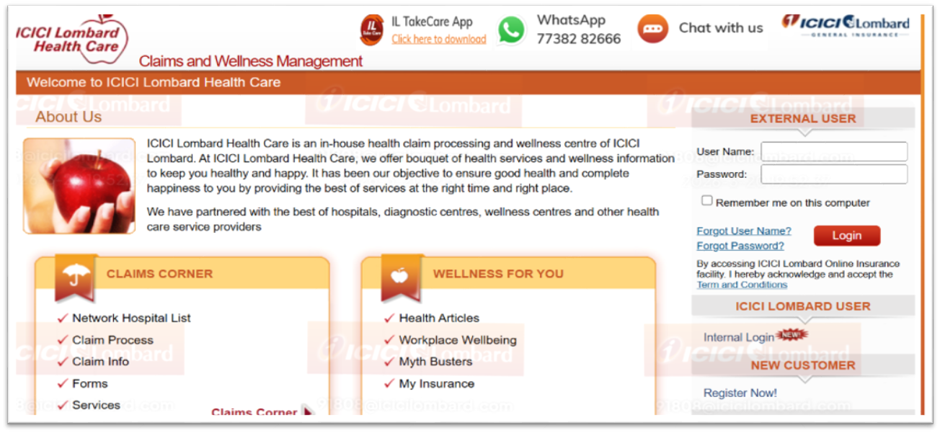
Click on the link and select “Internal Login” (SSO Link no user ID password required)

Do not have access to the portal?
Please raise a LAM request using the link below:
https://lamgroup.icicibankltd.com/LA_RequestForm.aspx
The steps to raise the LAM request are provided at the end of the PDF.

Home Page: After logging in, select the required policy number from the dropdown menu and click on “Policy Details”
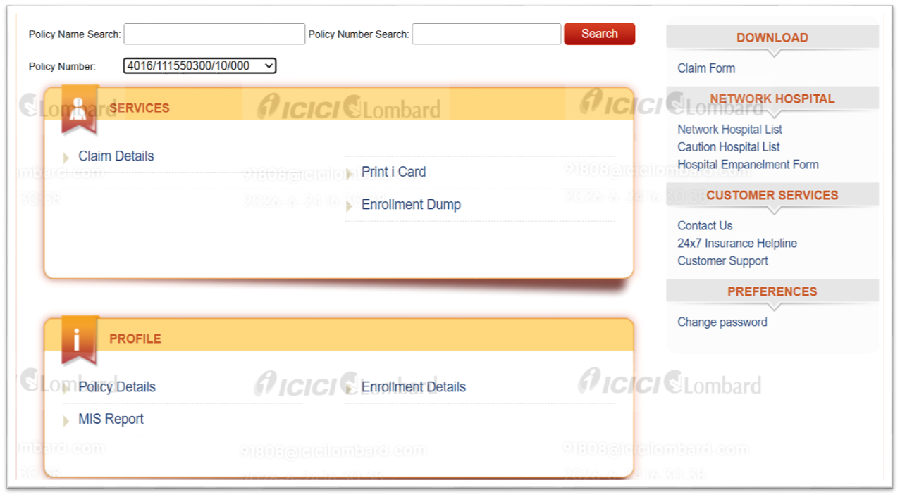

MIS Report - You can download the expired policy line-item data only by clicking on ‘MIS Report’ (Policies sourced through Pathfinder only).

Policy Details - After clicking on “Policy Details,” users will be redirected to the page shown below, where they need to click on “Policy Performance Report.” (This is available only for Active policies sourced through Pathfinder)
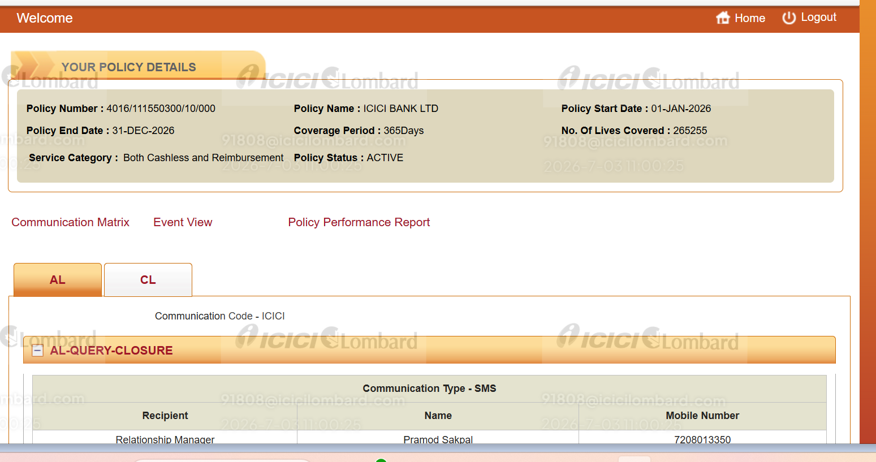

Upon clicking the “Policy Performance Report”, users will be directed to a page where they can view all policy level insights.

Report Catalog (Insights)

Portfolio
- Policy Premium and Loss Ratio Details

- This table provides details on total lives covered and the overall premium received.
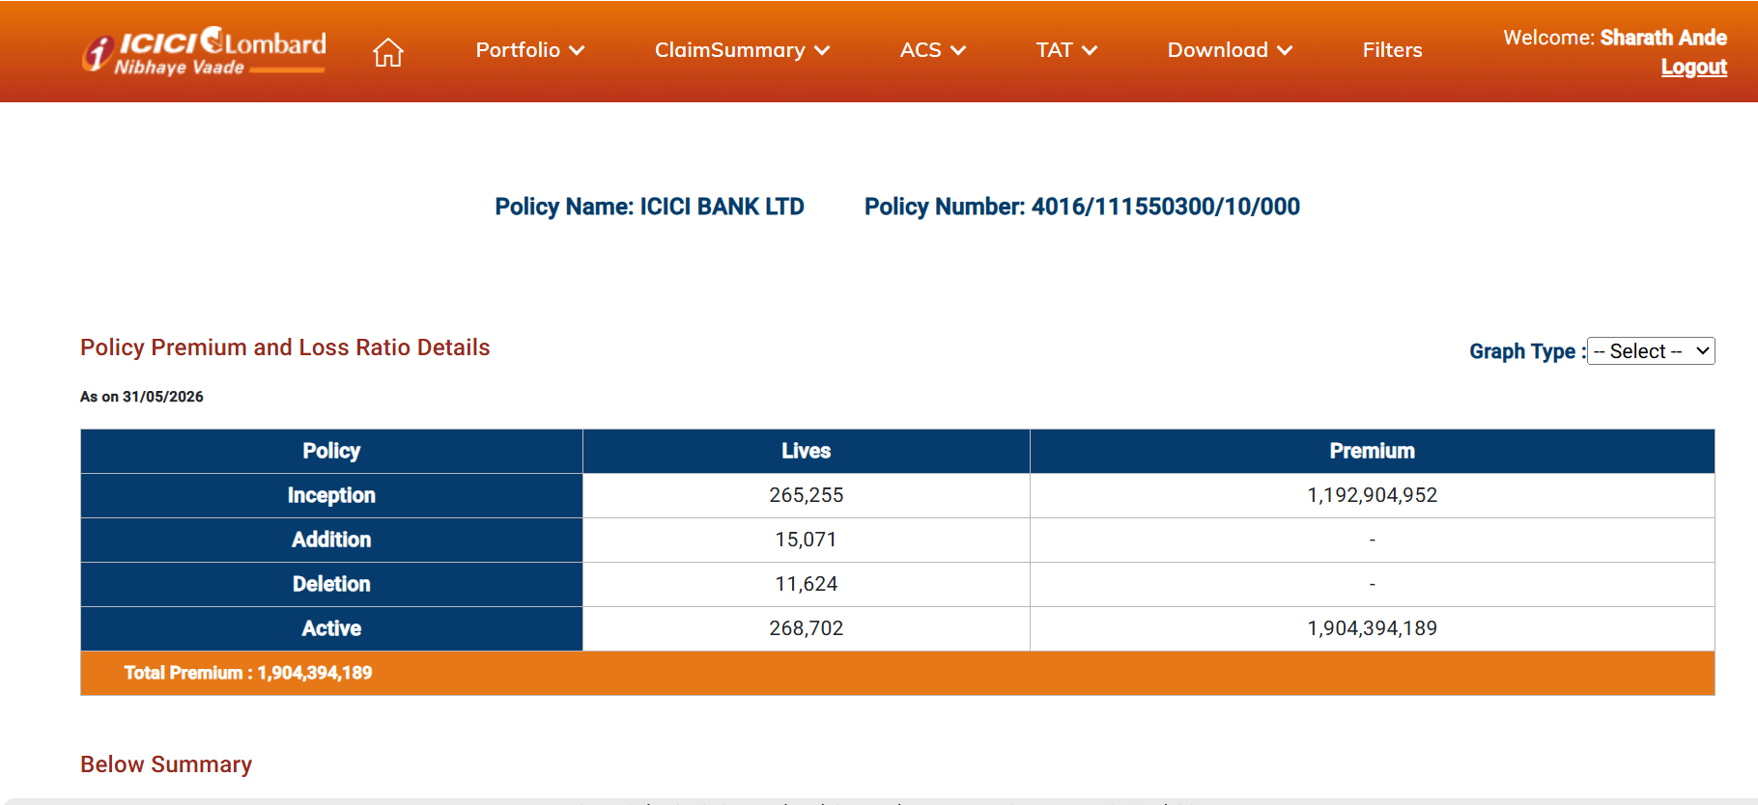

Scroll down to view the Summary section, which includes details on Incurred Cost Loss Ratio (LR) and Projected Loss Ratio (LR).
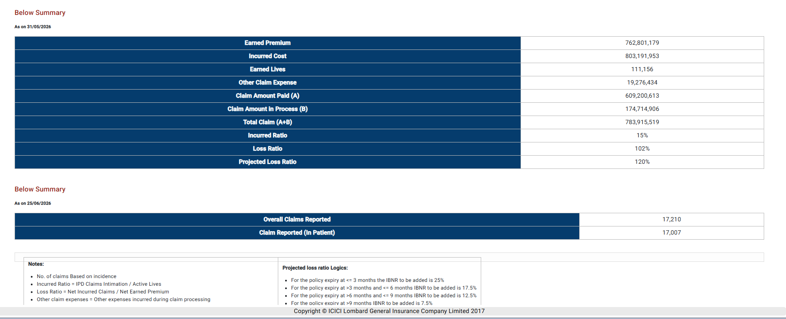

  - Enrollment Summary
From the Portfolio dropdown, click on “Enrollment Summary.”
This section provides insights into age band-wise enrollment, relationship-wise distribution, and the Morbidity Summary.
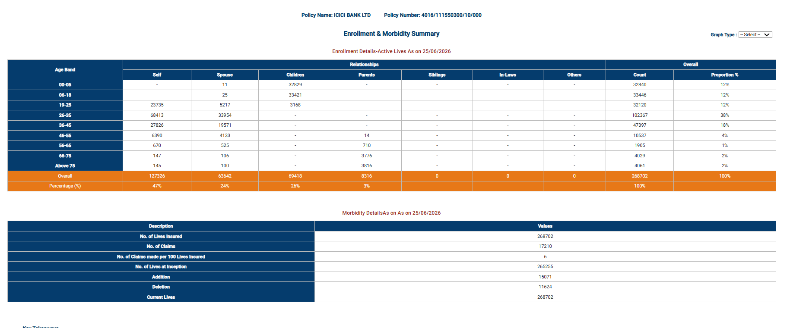

Claim Summary
Navigate to “Claim Summary” and choose the relevant option from the dropdown to view claim details.

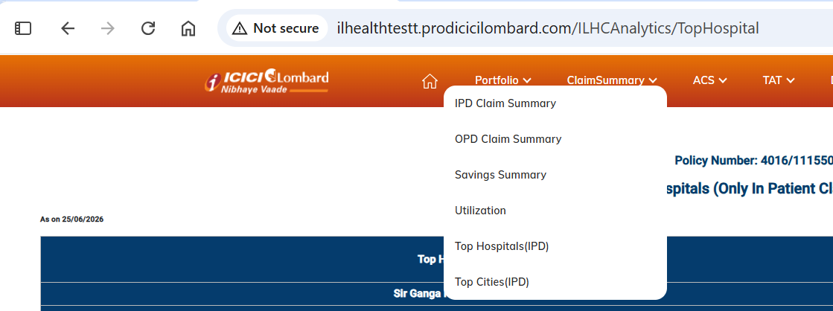

- IPD Claim Summary – This report shows the claim status of Overall and IPD claims along with its value and percentage break up – categorized by Cashless and Reimbursement.

- OPD Claim Summary – This report shows the claim status of Overall and OPD claims along with its value and percentage break up – categorized by Cashless and Reimbursement.

- Savings Summary – This report shows the savings achieved on claims – through policy-driven deductions (Deductible, Co-Pay) and other savings (Hospital Discounts) along with claims Count and Saving Amount. It also shows the Reimbursement Intimations done through IL Take care app against total Reimbursement intimation.

- Utilization – This shows the number of times an employee has availed claims under the current policy, along with the total claim amount and the percentage.

- Top Hospitals (IPD) – This report shows the top hospitals with the highest claims spends (Inpatient only), along with the number of claims, claim amount, and Average Claims Size (ACS) – split across Overall, Cashless and Reimbursement Claims

- Top Cities (IPD) - This report shows the top cities with the highest claims spends (Inpatient only), along with the number of claims, claim amount, and Average Claims Size (ACS) – split across Overall, Cashless and Reimbursement Claims

ACS (Average Claim Size)


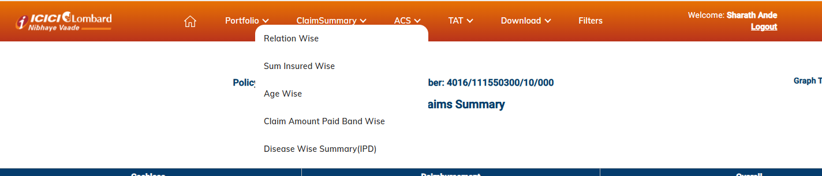
Click on “ACS” and select the desired option from the drop down menu.

- Relation Wise – This report shows the relation-wise breakup of paid claims, with the number of claims, claim amount, and Average Claims Size (ACS) – split across Cashless, Reimbursement, and also for Overall claims, IPD claims

- Sum Insured Wise – This report shows a sum insured band-wise breakdown of paid claims by count, amount, and ACS across Cashless, Reimbursement, and Overall categories, along with separate IPD claims analysis.

- Age Wise Break Up – This report shows an age-wise breakdown of paid claims by count, amount, and ACS across Cashless, Reimbursement, and Overall categories, along with separate IPD claims analysis.

- Amount Band Wise: This report shows a paid amount band-wise breakdown of claims by count, amount, and ACS across Cashless, Reimbursement, and Overall categories, with separate IPD claims analysis.

- Disease Wise Claims (IPD): This report shows disease category wise breakdown of IPD paid claims by count, amount, and ACS across Cashless, Reimbursement, and Overall Claim categories.

TAT

Click on “TAT” and select the desired option from the dropdown menu.

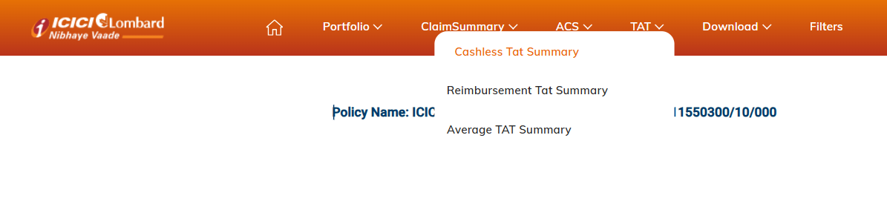
- Cashless TAT Summary: This report will show the claim processing turnaround time (TAT) for cashless claims across different time buckets for initial and final approvals.

- Reimbursement TAT Summary: Reimbursement TAT: This report will show the claim processing TAT for reimbursement claims across different day-based time buckets.

- Average TAT Summary: This report shows the average claim processing turnaround time for cashless (in hours) and reimbursement (in days), with a month-wise bifurcation.

Download
All Reports can be downloaded in excel or pdf format by using the Download feature


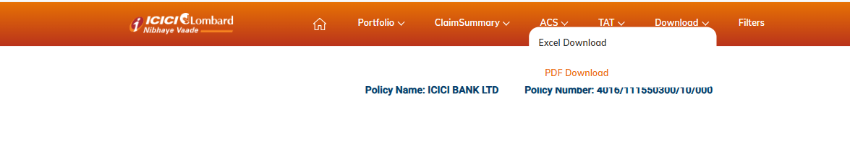


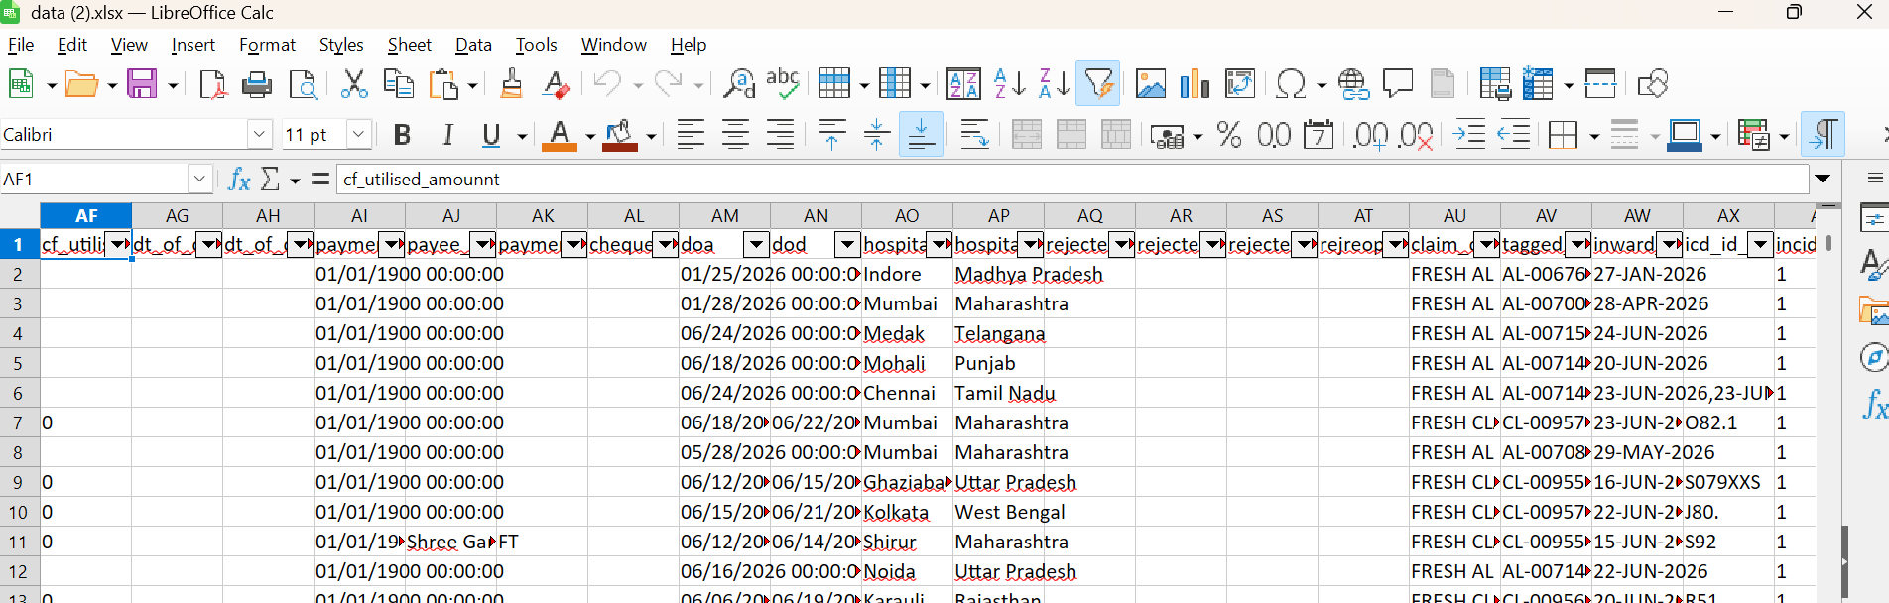

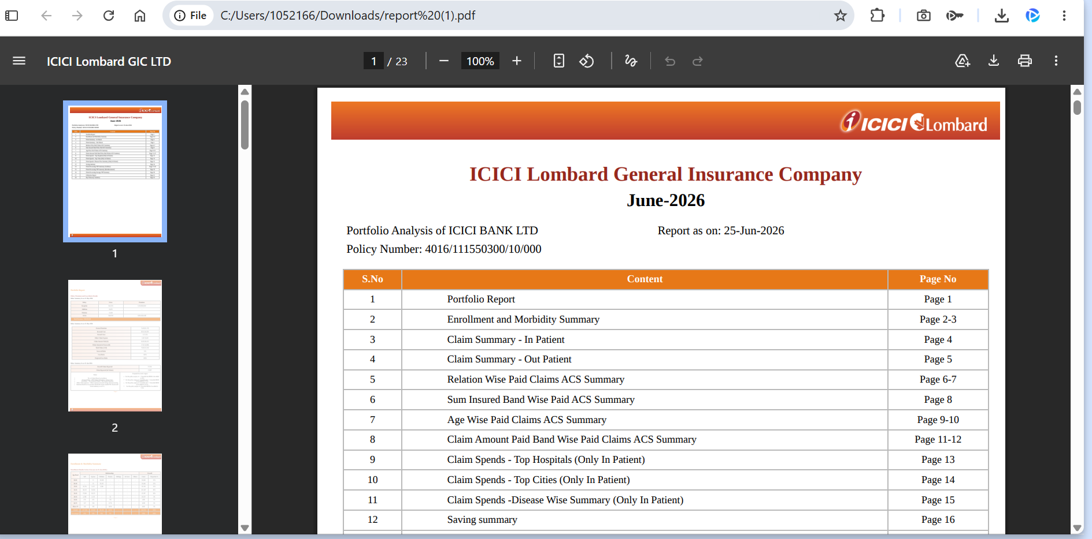

Filters

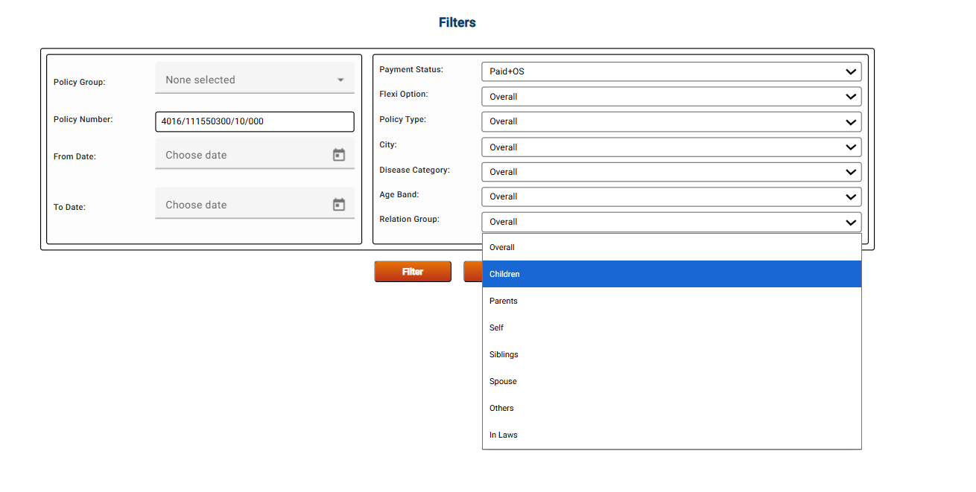
Through this page you can apply filters on Disease category, Age Band, Relation Group

Steps to Raise a LAM Request
LAM Portal Link - https://lamgroup.icicibankltd.com/LA_RequestForm.aspx
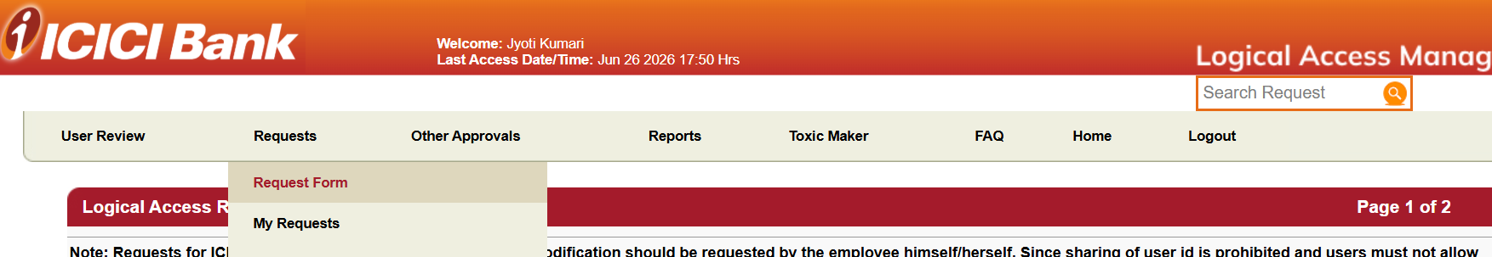

1. Click on Request Form
2. Select Application Name* as “IL Health Care (ILHC)”
3. Select “CREATE ID” from the Activity* dropdown

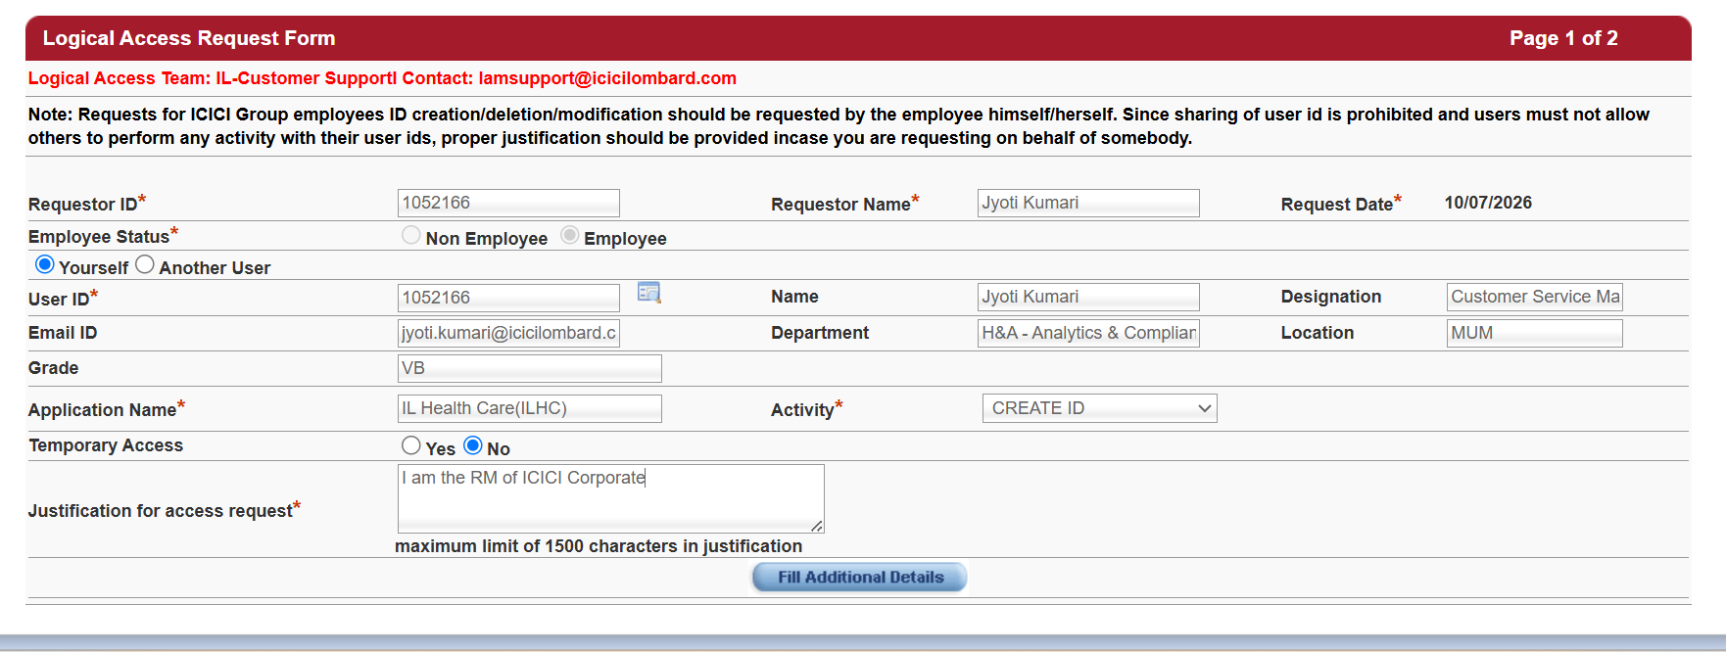
4. Enter details under Justification for access request*

5. Click on Fill Additional Details
6. Select Branch Location
7. Choose Network Access*
8. Enter the Policy Number for which access is required
9. Select Access Role “Admin / Corporate”
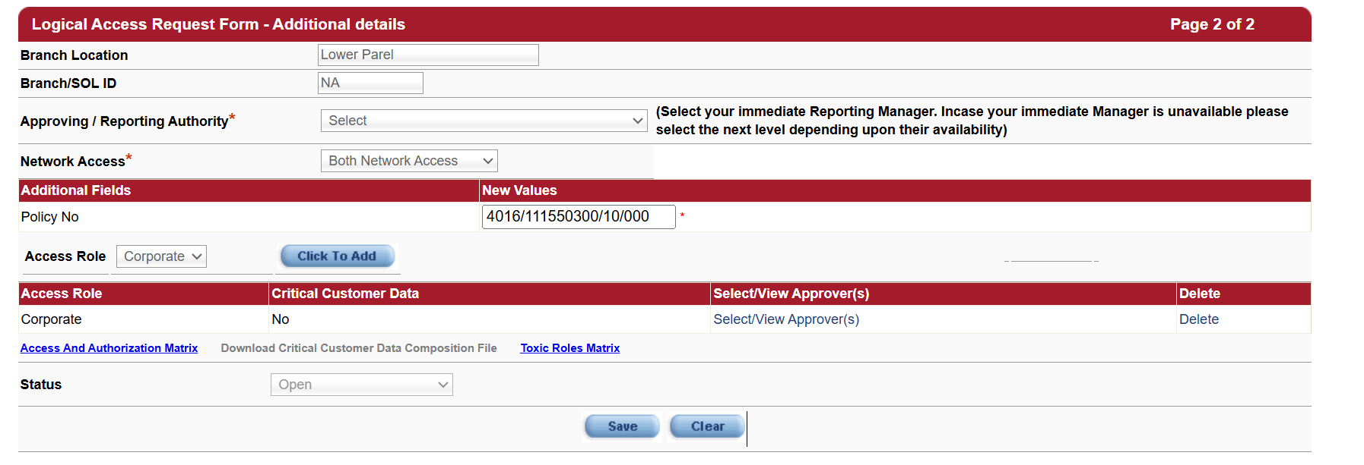
10. Click on Select/View Approver(s)

11. Choose the approver from the list - Click Save - Then Close
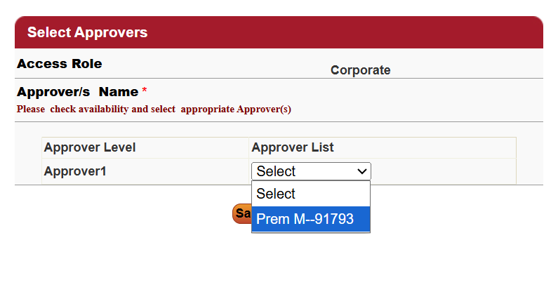
12. Click Save on the main page to submit your request
Your LAM request will be created successfully.
You will be able to access the portal once the approvals are completed.

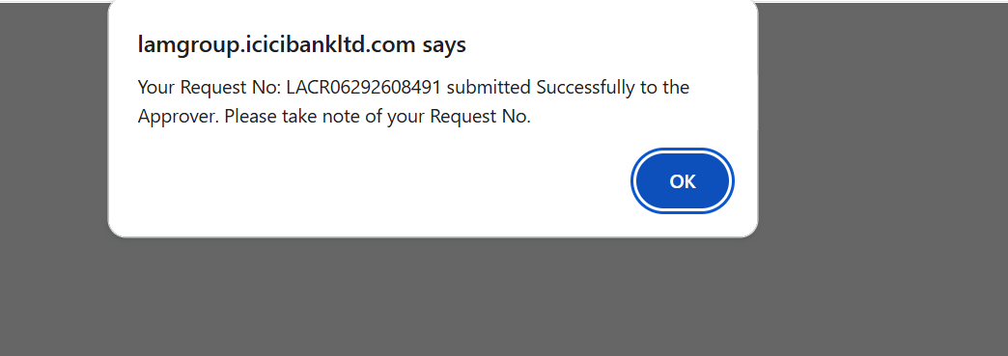

Frequently Asked Questions(FAQs)

Q1. Do we have all policy data available in the portal?
No. The ILHC Portal currently provides access to active policies and policies sourced through Pathfinder. Data for Artemis-sourced policies is under development and will be made available in the portal soon.

Q2. What is the data refresh frequency in the portal?
The claims data is refreshed daily by 10:00 AM on the portal.

Q3. How can I get access to the ILHC Portal?
To obtain access, you must raise a LAM (Logical Access Management) Request mapped to the relevant policy number.
Steps to raise request:
- Open the LAM Portal.
- Select Application Name = IL Health Care (ILHC).
- Select Activity = CREATE ID.
- Enter the required policy number.
- Select the appropriate approver and submit the request.
- The detailed LAM creation process is available in the User Guide.

Q4. Can I view all the GHI policies?
Only active policies are visible in the ILHC Portal.
For a policy to appear, it must be correctly mapped to you (the RM) in the system.

If you are unable to see a policy in the dropdown list, please ensure that the necessary endorsement is processed and that the policy is mapped to your RM ID in the system.
Once the mapping is completed, the policy will sync automatically to the portal.
TAT: T + 1 day after endorsement.

Q5. Can reports be downloaded from the ILHC Portal?
Yes. All reports available in the portal can be downloaded in Excel & PDF Format using the Download functionality available within the portal.

SPOC List
For any concerns or queries related to the data, please contact the designated SPOCs as outlined in the escalation matrix below.
Level | Contact Person | Contact Details
Level I | Sharath Ande /CS/ICICILOMBARD/HYD | 📧 91808@icicilombard.com  📞 +91 9703216449
Level II | Koushikkumar Veeramalla /CS/ICICILOMBARD/HYD | 📧 1047557@icicilombard.com  📞 +91 7893170345
Level III | Umakant Palnati /CS/ICICILOMBARD/HYD | 📧 84379@icicilombard.com  📞 +91 7799881941
Escalations | Amit Kumar /CS/ICICILOMBARD/PRBD | 📧 a.kumar@icicilombard.com  📞 +91 7304590377

